FLOOD MANAGEMENT BASED ON IOT

# Project Overview:

This project based on the Internet Of Things that is Flood Management . How we can detect the flood before coming ,this is our project On this project the apparatus required shown belows;

# BLOCK DIAGRAM

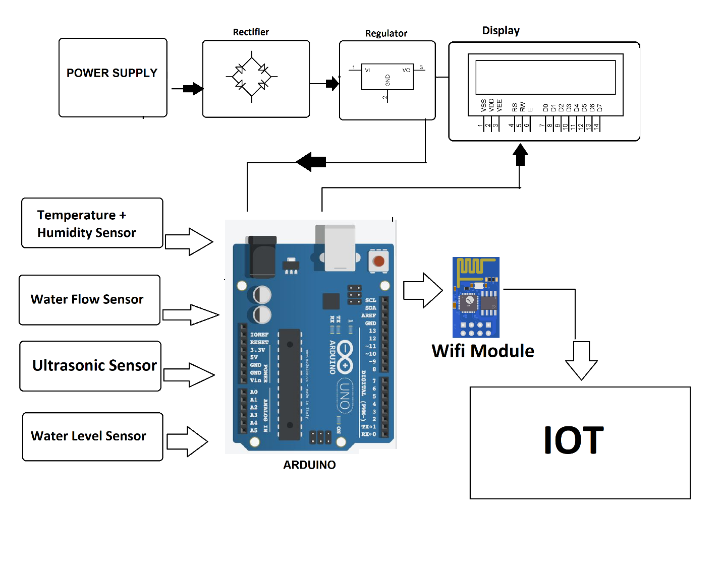

STEPS / INNOVATION IN FLOOD MANAGEMENT:

**1 MAINTENANCE OF EXISTING INFRASTRUCTURE**

**2 INDIVIDUAL FLOOD PROOFING MEASURE**

**3 IMPROVE TRAFFIC ACCESS**

1. **PROPERTY SURVEY**

**5 LAND USE PLANING CONTROL**

**6 BUILDING AND DEVLOPMENT CONTROLS**

**7 CATCHMENT FLOOD MODELLING**

**THIS DESIGN THINKS WAS SUBMITTED BY AN**

**NAME** : P.RAMNIVASS

**EMAIL : gg7868500@gmail.com**

**PROJECT TITTLE** : Flood Management

**ROLL NO** : 713921106042